MARVELLOUS ISIJOLA

Data Profiling

Seattle’s weather

Seattle, a city on Puget Sound in the Pacific Northwest, is surrounded by water, mountains and evergreen forests, and contains thousands of acres of parkland. Washington State’s largest city, it’s home to a large tech industry, with Microsoft and Amazon headquartered in its metropolitan area. The futuristic Space Needle, a 1962 World’s Fair legacy, is its most iconic landmark.

For my data profiling assignment, I have found a spreadsheet containing Seattle’s weather from the beginning of 2012 to the end of 2013.

INFORMATION ON THE DATASET

This dataset talks about the precipitation

ANALYSIS OF WEATHER 2012

Winter (From January):

Cells being reviewed: 2 to 93.

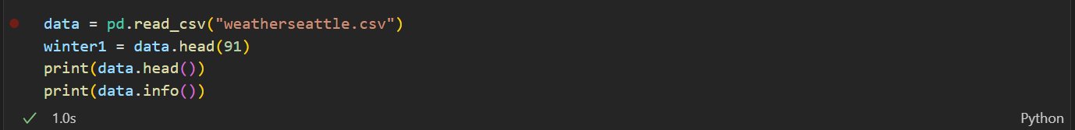



By means of conducting a specific excel search as shown above, I have found that it mostly rained with the minimum temperature at its lowest being at -3.3 degrees Celsius and the highest minimum temperature is 7.8 degrees Celsius. The lowest max temperature of the winter of 2012 was -1.1 degrees Celsius and the highest max temperature 16.1 degrees Celsius. It had an average precipitation of 4.92 inches and an average wind speed of 4.01.

Spring:

By means of conducting another specific excel search as well as using functions to determine the outputs about to be listed, I have found that it mostly rained again with an average wind speed of 3.38. The lowest temperature recorded was 1.7 degrees Celsius and the highest was 26.7 degrees Celsius. It had an average precipitation of 2.06 inches.

Summer:

By means of conducting yet another specific excel search as well as using functions to determine the outputs about to be listed, I have found that it was mostly sunny as it should be for summer season, with an average wind speed of 2.89. The lowest temperature recorded was 8.9 degrees Celsius and the highest temperature recorded was 34.4 degrees Celsius. It had an average precipitation of 0.63 inches.

Autumn:

Using the same methods as the one used above, I have found that it mostly rained again – it seems Seattle is a very wet State- with rain pouring down 41 times throughout the season, with an average wind speed of 4.67 The lowest temperature recorded was -0.6 degrees Celsius and the highest temperature recorded was 27.8 degrees Celsius. It had an average precipitation of 4.67 inches.

ANALYSIS OF WEATHER 2013

Winter (From November 2012):

I have found that in this season, it mostly rained with an average wind speed of 3.46. The lowest temperature recorded was -4.4 degrees Celsius and the highest temperature recorded was 15 degrees Celsius. It had an average precipitation of 3.75 inches.

Spring:

I have found that in this season, it was mostly sunny as it was sunny for the largest number of days out spring with it being recorded sunny 55 times throughout the season, it had an average wind speed of 3.39. The lowest temperature recorded was 0 degrees Celsius and the highest temperature recorded was 30.6 degrees Celsius. It had an average precipitation of 2.56 inches.

Summer:

I have found that in this season, it was mostly sunny, as it should be for summer, with an average windspeed of 2.51. The lowest temperature recorded was 11.1 degrees Celsius and the highest temperature recorded was 33.9 degrees Celsius. It had an average precipitation of 1.65 inches.

Autumn:

I have found that in this season, it was mostly rained, as it should because autumn is supposed to wet, with an average wind speed of 2.51. The lowest temperature recorded was -0.5 degrees Celsius and the highest temperature recorded was 25.6 degrees Celsius. It had an average precipitation of 3.21 inches.

Winter (From November to the end of December):

During this period, it was mostly sunny, surprisingly, and even more surprising it only snowed once. It had an average wind speed of 2.65. The lowest temperature recorded was -7.1 degrees Celsius and the highest temperature recorded was 14.4 degrees. It had an average precipitation of 1.29 inches.